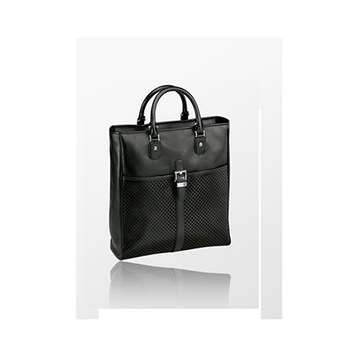

Montblanc Tote Bag

PRODUCT DETAILS

**Material: Leather**

**Material: Stainless Steel**

**Color: Black**

**Dimensions: 35 x 38.5 x 11 cm**